JBC Soldering

Modular Line DD-2E Two tool Control Unit
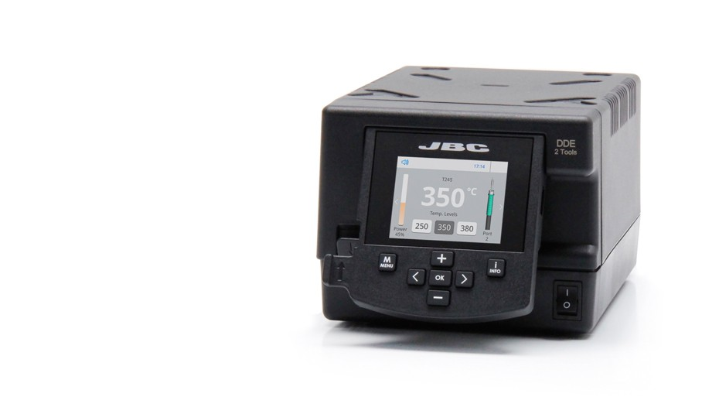
This control unit manages up to 2 tools simultaneously. It offers full connectivity to any JBC soldering or desoldering tools.

It works with the JBC exclusive heating system and the intelligent sleep & hibernation modes.

It features all the Excellence range benefits such as station customization, full control of soldering processes and remote work management.

The easy-to-use menu offers innovative functions to help you monitor the work in real time: graphics, partial counters or tool port monitoring.

For a basic working system, you need 1 stand, 1 tool and 1 cartridge.

Specifications
Weight | 3.815 kg (8.41 lb)
Dimensions | 148 x 120 x 232 mm
Voltage(AC) | 120V / 230V / 100V
Input fuse | 4A / 2A / 5A
Output peak power | 150W per tool
Temperature selection | 90-450 ºC (190-840 ºF)
Idle temp. stability (still air) | ±1.5 ºC (±3 ºF)
Tip to ground resistance | <2 ohms
Tip to ground voltage | <2 mV RMS
Ambient operating temp. | 10-40 ºC (50-104 ºF)
Communication connectors | USB-A / USB-B / Peripherals
Robot connector | RJ12 for RS-232 protocol
ESD safe
Package weight | 4.269 kg (9.41 lb)
Package dimensions | 258 x 328 x 208 mm

DME
4 Tools Control Unit
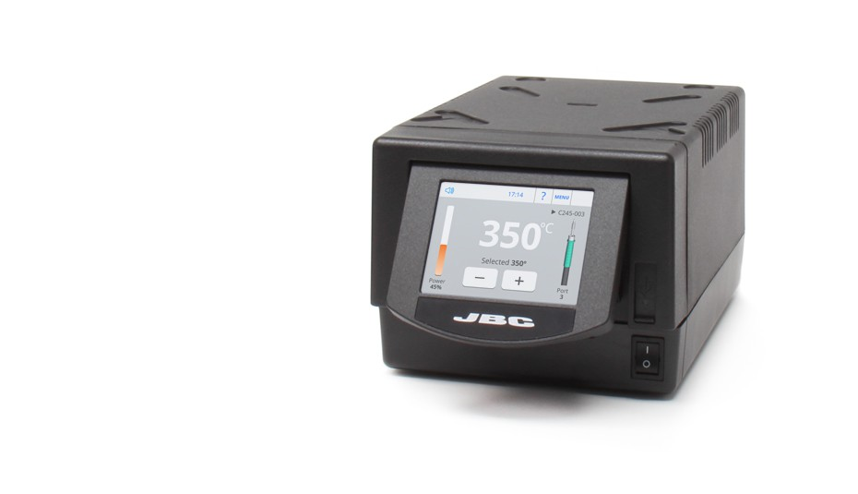
The DME manages up to 4 tools simultaneously and it is fully compatible with most of JBC tools.

It works with the JBC exclusive heating system and the intelligent sleep & hibernation modes.

It features all the Excellence range benefits such as station customization, full control over the soldering process and remote work management.

The easy-to-use menu helps you monitor the work in real time: graphics, partial counters or simultaneous control of ports.

The DME also provides you with extra applications that support your work: USB microscope, file storage, unit converter, video, etc.

For a basic working system, you need 1 stand, 1 tool and 1 cartridge.
Specifications
Weight | 3.5 kg (7.8 lb)
Dimensions | 148 x 120 x 232 mm
Voltage(AC) | 120V / 230V / 100V
Input fuse | 6A / 3.15A / 8A
Output peak power | 160W per tool
Temperature selection | 90-450 ºC (190-840 ºF)
Idle temp. stability (still air) | ±1.5 ºC (±3 ºF)
Tip to ground resistance | <2 ohms
Tip to ground voltage | <2 mV RMS
Ambient operating temp. | 10-40 ºC (50-104 ºF)
Communication connectors | USB-A / USB-B / Peripherals
Robot connector | RJ12
PS connector | RJ12
LAN (Ethernet) | RJ45
ESD safe
Package weight | 4.1 kg (9 lb)
Package dimensions | 300 x 275 x 135 mm

Handles for Tools

T245-A
General Purpose Handle
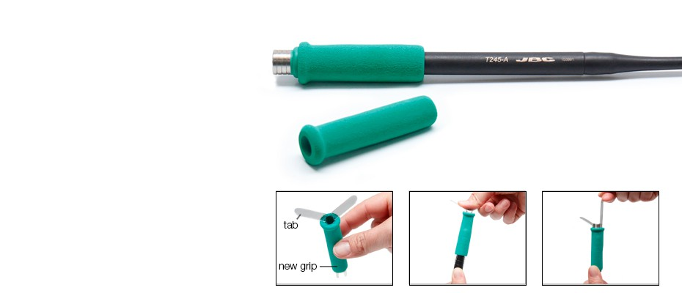
This soldering iron handle for general purposes features a soft foam grip which provides thermal insulation. Is perfect for both SMD components and for jobs with high power requirements (e.g. ground plane soldering).

Its ergonomic handle and the short distance tip-to-grip ensure greater results and comfort
The cartridges can be easily replaced using the quick cartridge extractor of JBC´s stands.

Works with C245 cartridges
Easy grip replacement

Stands for Modual Unts ( More Available)
Using the fitters you can easily change the damaged grips (Ref. 0016057).

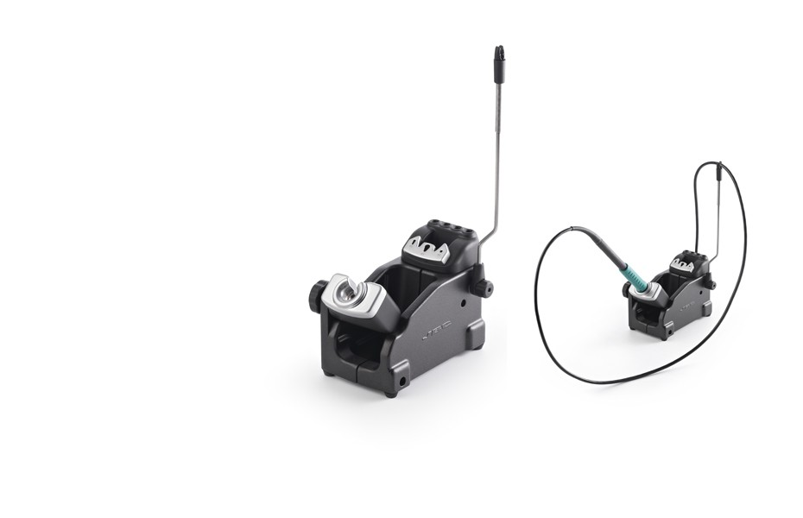
JBC´s stands feature a line-up covering Advanced Series tools range.

The sleep mode automatically reduces the tip temperature when the tool is in the stand. As a result, a tip`s life lasts up to 5 times longer.

The quick cartridge changer allows to switch between cartridges without interrupting your work.

Moreover, the AD-SE allows you to easily store up to 4 cartridges.

The tool holder and the cable collector are easily adjustable to suit your work position and to keep the working area free of cable.

All stands are compatible with all Modular stations.

Stands & The Intelligent Heat Management
Quick Tip Changer
Insert the cartridge, remove it and introduce a new one without having to turn off the station.
This allows you to work
on different soldering jobs.
Intelligent Heat Management
The stations incorporate the sleep & hibernation features.
As a result, a JBC tip life lasts up to 5 times longer
than other brands.
Suit position
JBC stands are designed to suit the user's work position.
The tool holder and the cable collector are easily adjustable.

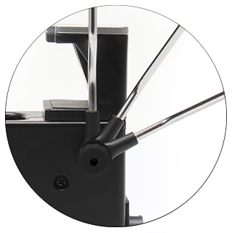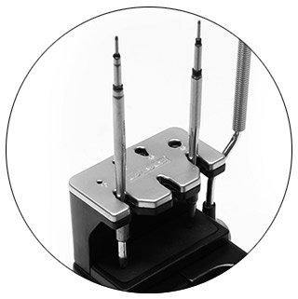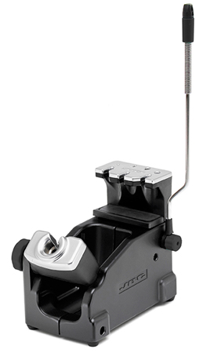

Modular line

